*[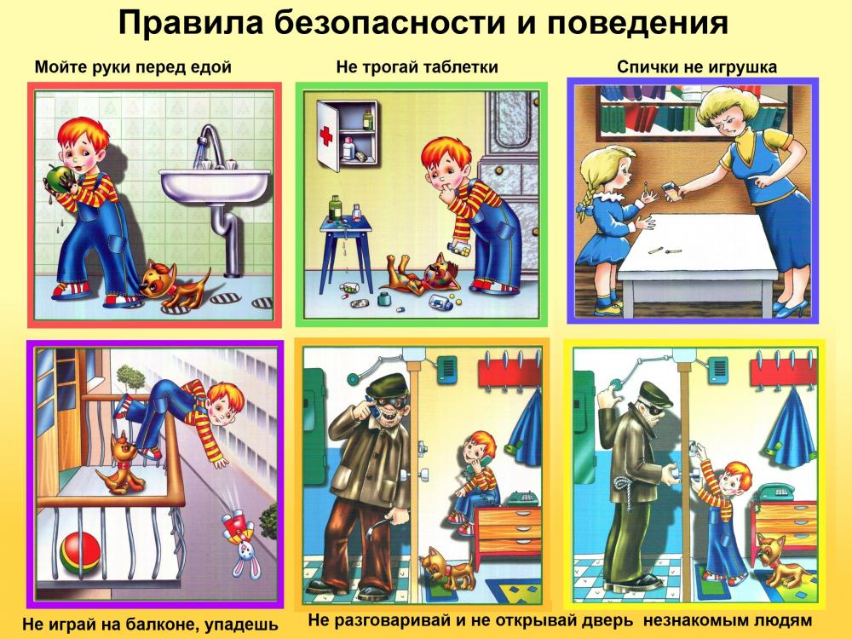](https://pp.userapi.com/c638120/v638120614/3bb72/wGUUR9QD2lc.jpg)*

*[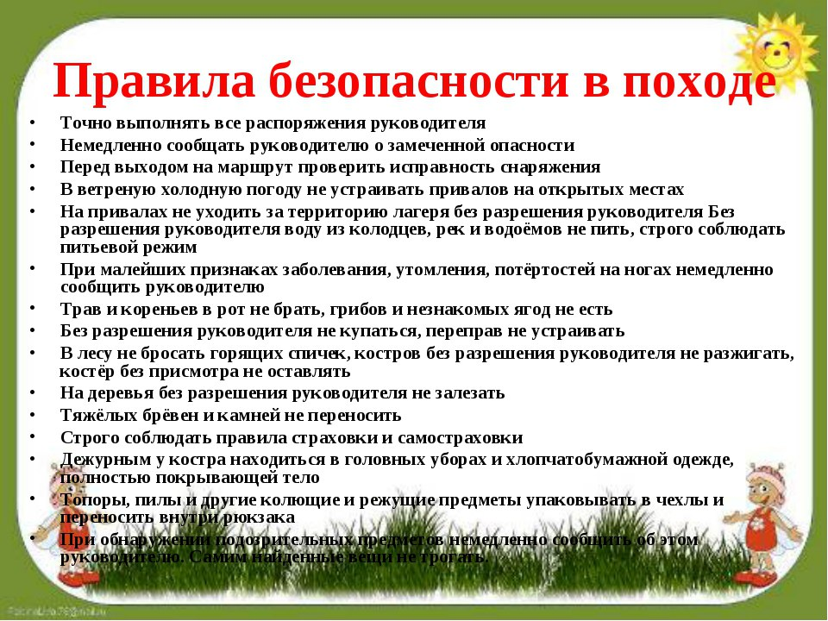](https://pp.userapi.com/c638120/v638120614/3bb7b/qShYgWp--hc.jpg)*

*[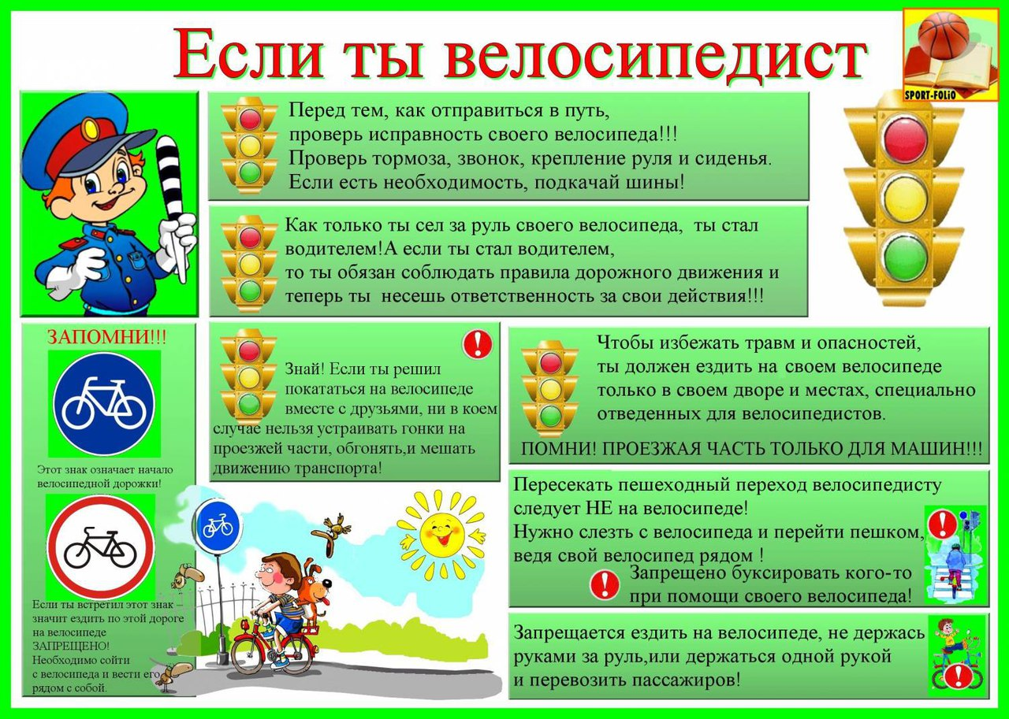](https://pp.userapi.com/c638120/v638120614/3bb96/hyoxBfROiiM.jpg)*

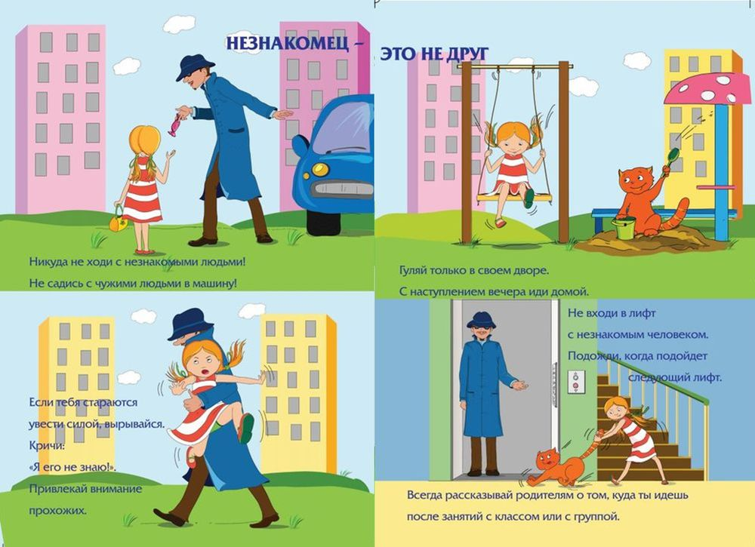

*[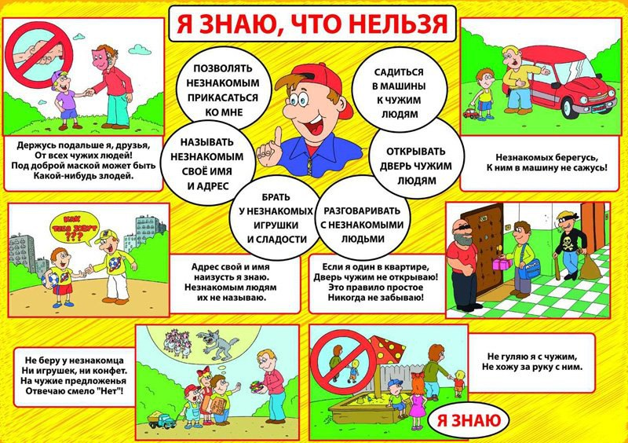](https://pp.userapi.com/c638120/v638120614/3bbb2/7vFleljzZLk.jpg)*

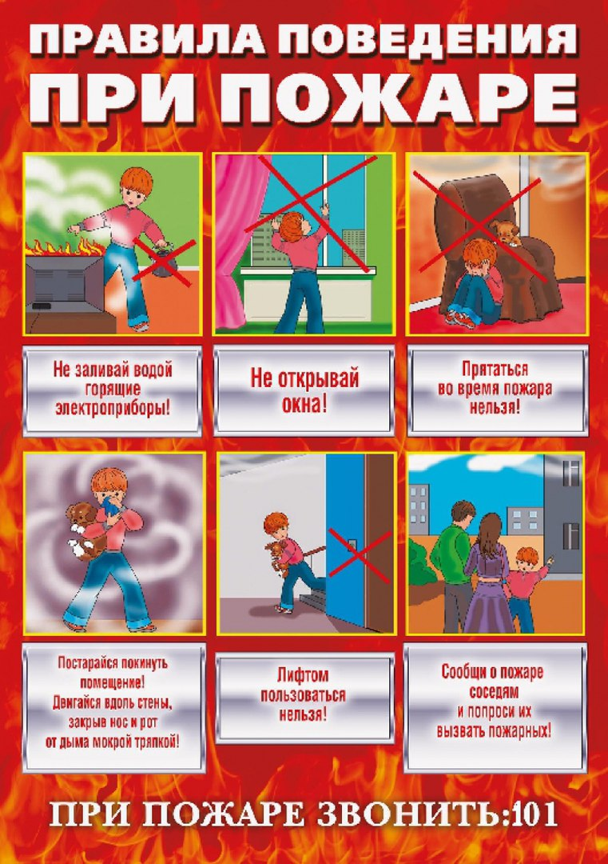

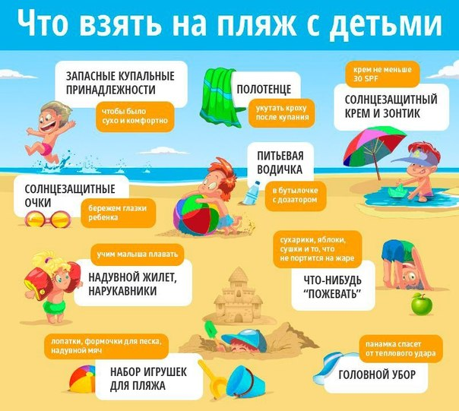

*[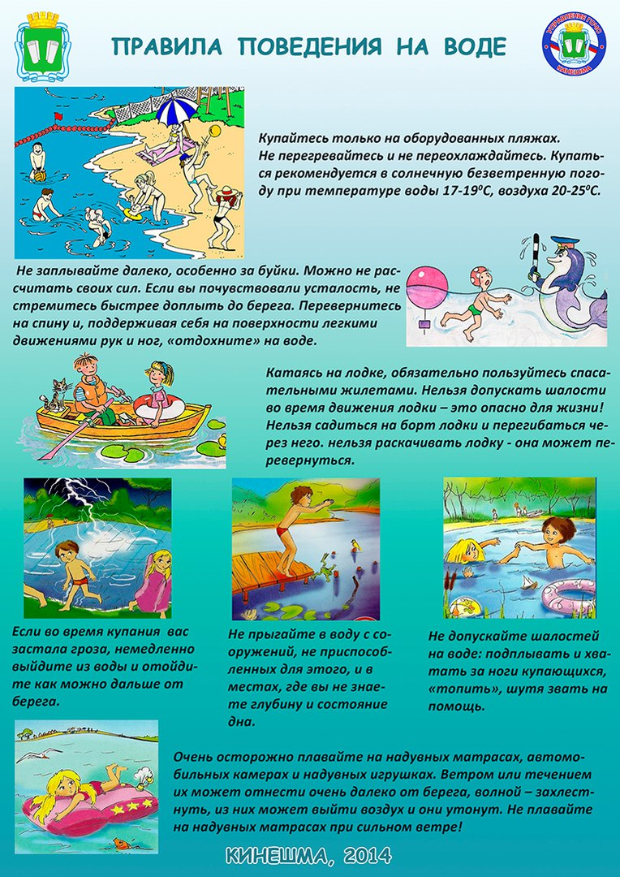](https://pp.userapi.com/c638120/v638120614/3bba0/hCa8389n6Sw.jpg)*

*[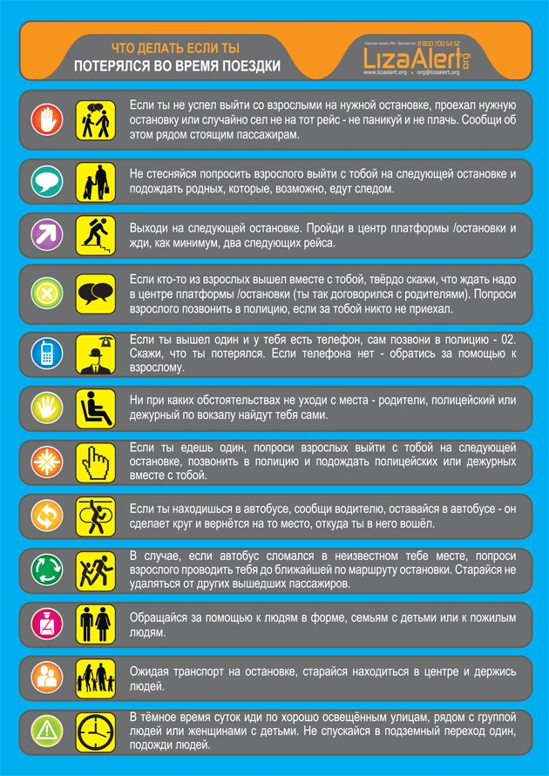](https://pp.userapi.com/c638120/v638120614/3bb8d/5hq76AMngn8.jpg)*